UNX511 - Lab 5
Student: David Rivera

Sysmon Exec output:
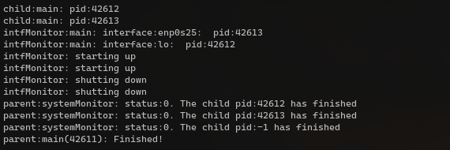
(Note that due to the fact that I’m using a different linux distribution other than ubuntu on vmware, the interface number is different in the output (s25).

AI Declarations
D1) 3
D2) 3

